March 15, 2025

Midterm Exam242

Computer Network Design (COE 546)

**Prof. Tarek Sheltami**

1.Configre the below network

2. For the multi-area osfp, make R2 the DR and R1 the BDR.

3. Summarize area 1 at ABR 1

4. For ISP,

a) establish static routes for end systems only.

b) Default gateway with interface loopback 1

Use summarized route whenever possible.

If the network is not connected, 30% will be deducted.

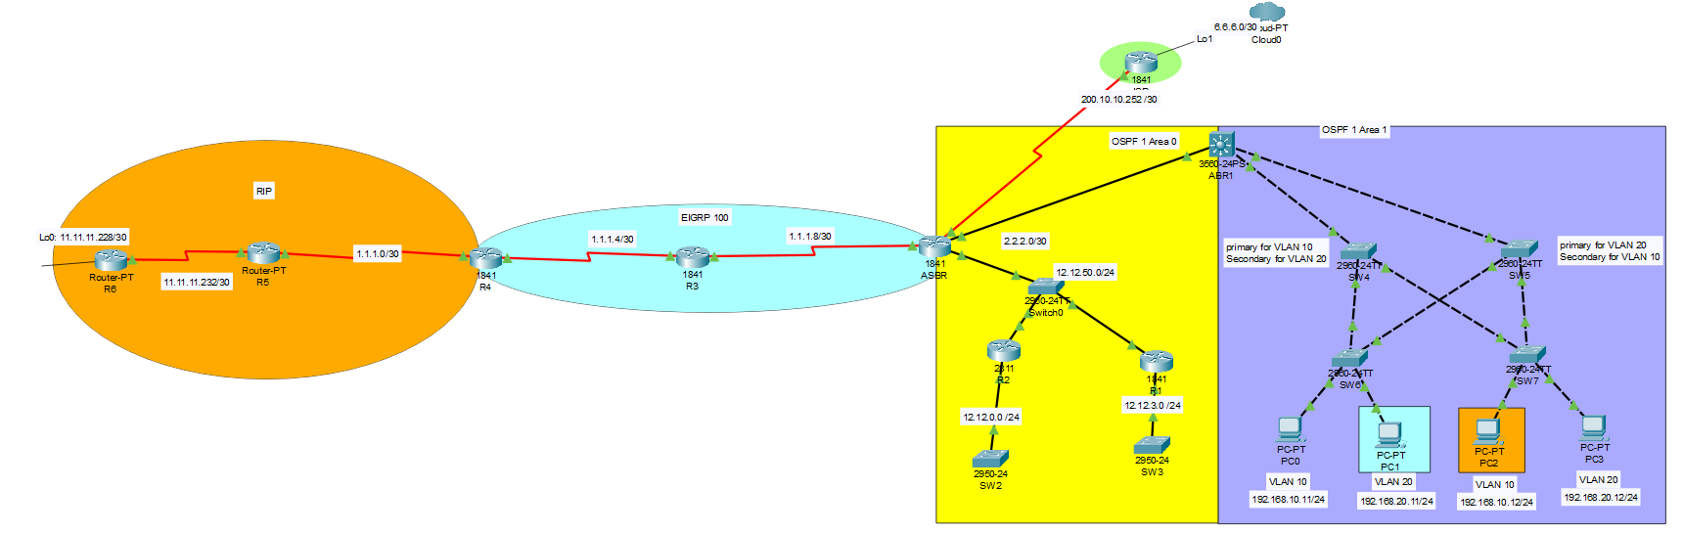

**Show screenshots of:**

1. **R6 15%**

show ip route rip

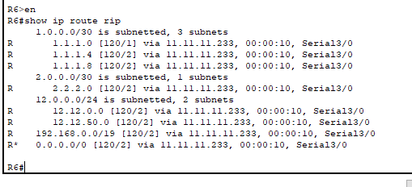

1. **R4 15%**

show ip route eigrp

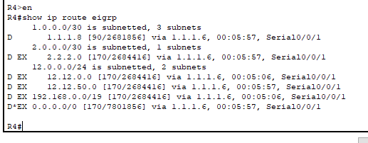

1. **ABR1 25%**

show run | sec Vlan

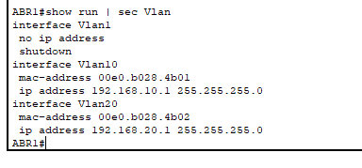

show run | sec dhcp

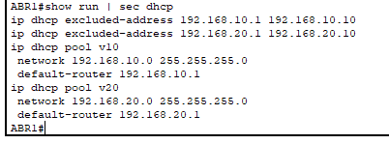

show ip route ospf

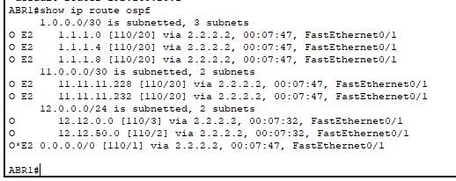

1. **ASBR 20%**

show ip route

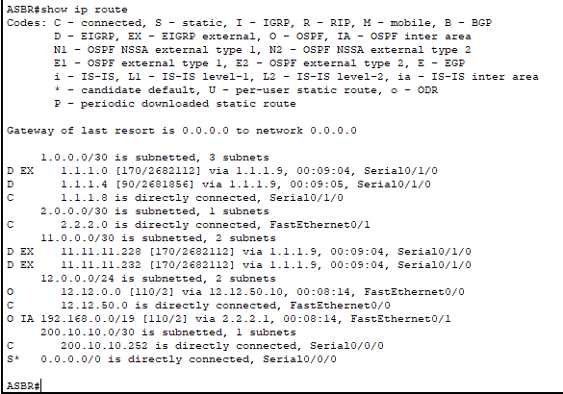

show ip ospf neighbor f0/0

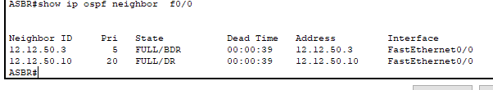

1. **ISP 5%**

show ip route

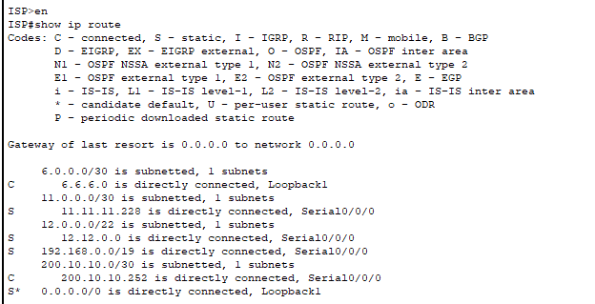

1. **SW4 5%**

show run | sec priority

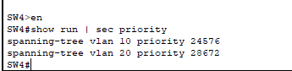

show run | sec interface “for interfaces f0/1 and f0/3)

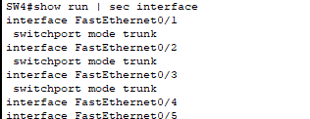

1. **SW5 5%**

show run | sec priority

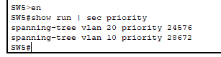

show run | sec interface “for interfaces f0/1 and f0/3)

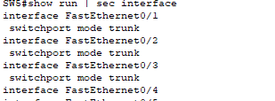

1. **SW6 5%**

show run | sec interface “for interfaces f0/1 and f0/2)

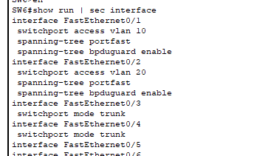

1. **SW7 5%**

show run | sec interface “for interfaces f0/1 and f0/2)

